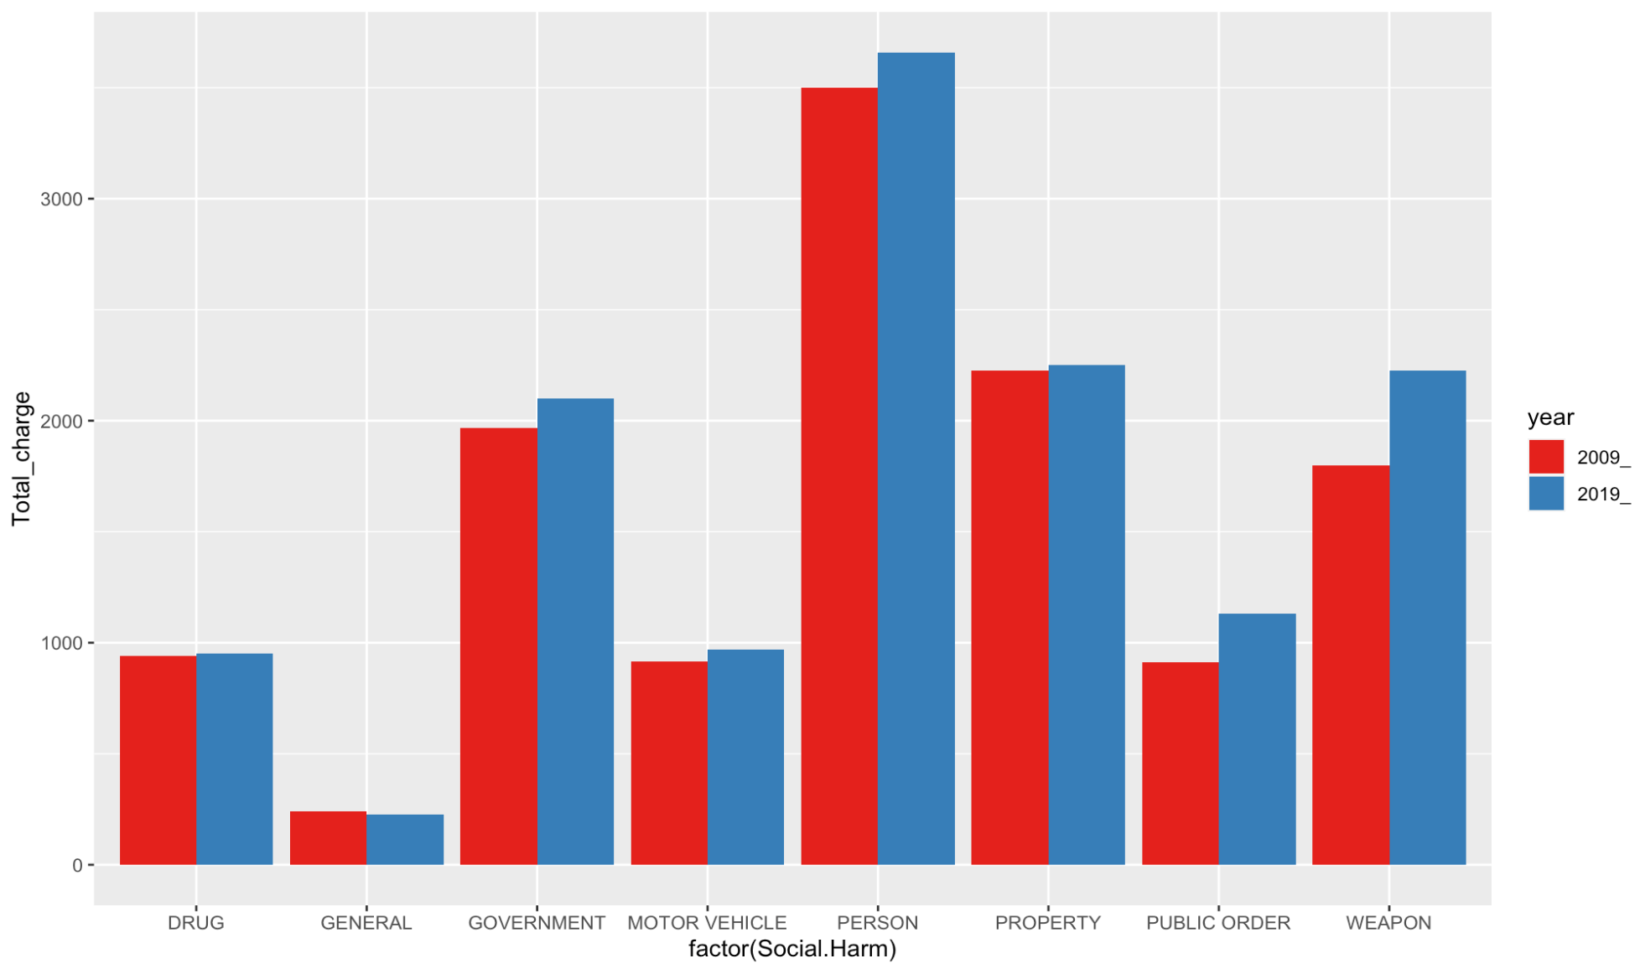

I was thinking to add all the percent of charge of black people for each type of social harm, and compare the values for 2009 and 2019 to see the growth of the charge. The x axis is the 8 types of social harm, and the y axis is the sum of total charges for black people. Red bars represent 2009 and blue bars represent 2019.

In those social harm, person charges the most for black people and drug charges the least. Charges for weapon growth most in these 10 years.

This graph is not accurate because there are some data that does not have an exact value like “<75”.

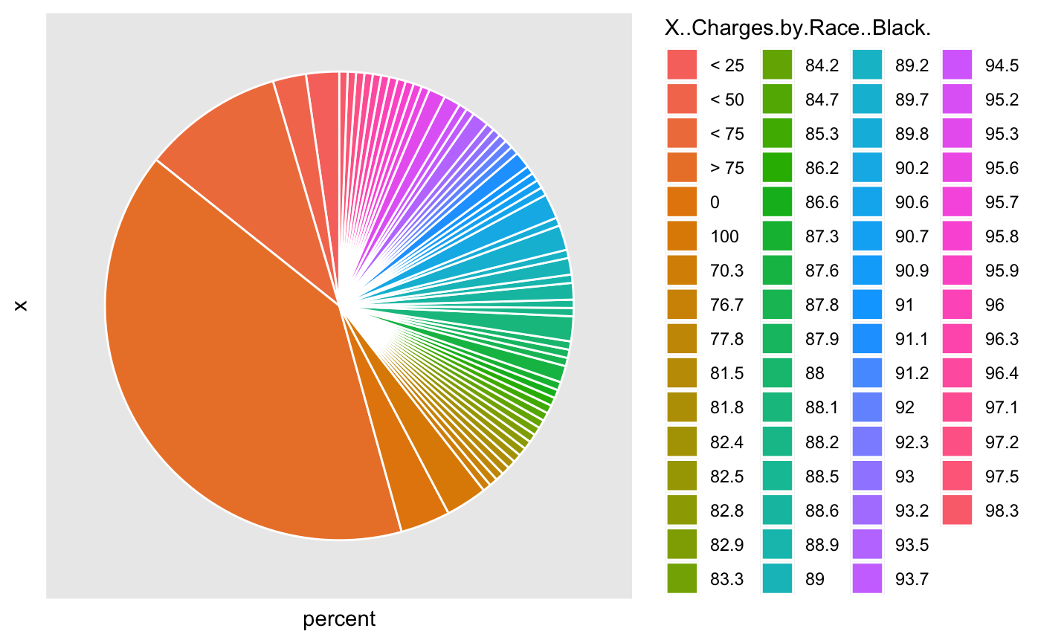

Each of the color represent a value or section of the percent charge of black people. Most of the charges are larger than 75%.

I am not sure the graph can be useful or not because I think it does not show any useful information. I will improve the chart later this week.

Number of black criminals(charged) changes through 2009-2019